Use 100% cotton with 3.75mm or US 5 needles. Using smaller needles gives this dishcloth a tighter stitch so it doesn’t stretch as much when wet.

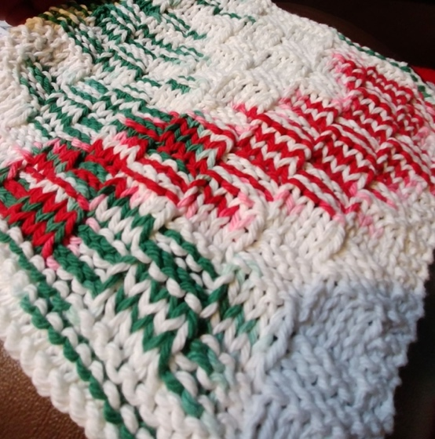
Instructions:
Cast on 39 sts.

Rows 1-4: Knit
Row 5: K3, *K3P3* to last 3 sts, K3
Row 6: K3, *P3K3* to last 3 sts, K3
Row 7: Repeat row 5
Row 8: Repeat row 6
Row 9: K3, *P3K3* to last 3 sts, K3
Row 10: K3, *K3P3* to lasts 3 sts, K3
Row 11: Repeat row 9
Row 12: Repeat row 10
Rows 13-52: Repeat rows 5-12 five times
Rows 53-56: Repeat rows 5-8
Rows 57-60: Knit
Cast off

